Mate 808_1080P FULL HD mini DV Manual
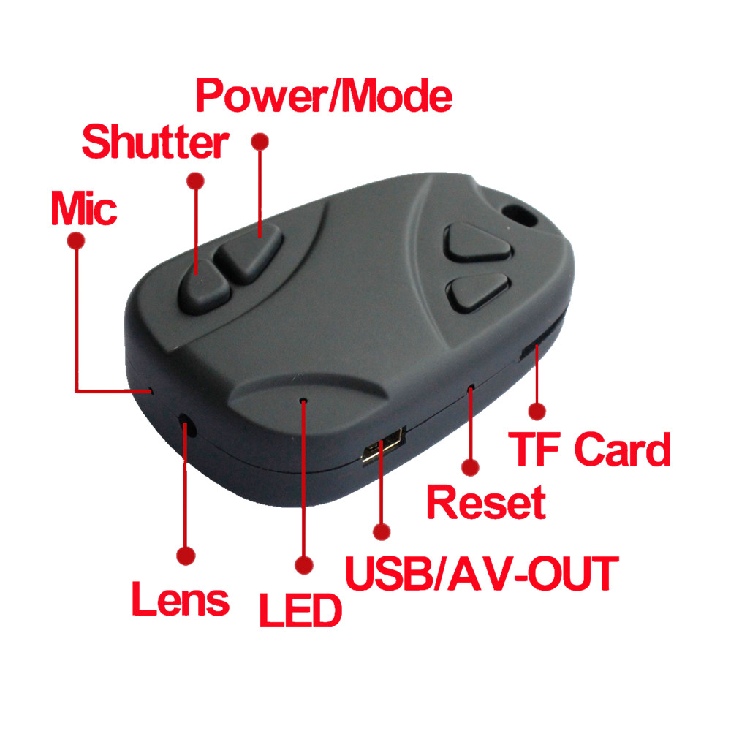
Specification:
- Video Format: 1920*1080P AVI,HD
- Lens: F/ON=2.0 70°& wide 120°
- Power Source: High capacity polymer li-thion Battery 250mA, it can recording 120 mins,and it’s changeable. with Battery Charger Manage IC
- Charg voltage:DC 5V
- USB type: Micro USB 2.0
- Memory:EX-slot for Macro SD card, support max 32GPackage
- Support system: Support all windows system, MAC OS LINUX and automatically distinguish operating system,install commensurate drive,do not need to install manually(Except windows98
- TV_out function
- Txt file Set the configuration function
- Motion detecting function
- HD PC webcam function
- Size：32*52*15mm
- Weight：20g
- Material: plastic

Operation Instruction:
- Power on/video: Short press power button 3 seconds to power on, yellow light on，then auto into recording Mode, the yellow light slow flashing.
- Stop video recording (standby status):
in the video recording status,Short press the shutter button to stop recording and save the video file, the yellow light flashes permanently,camera into standby status
- Switching of modes:in the standby status,press power button once switch to recording/take photo/motion detection mode,the yellow light flashing once
Taking photos:you can take a photo by short pressing the shutter button once,when the yellow light flashes once,it means a photo has been taken and saved.
Note:It will take some time to save a file.The interval to press the button shall not be too short for continuous photos
- Turn off:press power button 3 seconds,the camera turn off.all indicators arr off.
- TV-OUT: the yellow plug connected to TV video input interface, red plug connected to the TV audio input interface. turn on after the default video recording mode, press power button to switch to other mode.in the play mode,press the shutter button once to the next function
- Web Cam Mode: Turn off camera, Connect it to your PC and the camera will Default in USB mode.Press power button once,into web cam mode The icon of web cam appear in the page of “My Computer”.If this is the first time using web cam mode, drivers will be automatically downloaded to your PC.Press power button again into start USB mode.

- Charging: connect the Micro USB cable to compurer or the standards 5v output of charger,Red LED lights on shows in charging mode. Red LED lights off shows it had finished charging. charging time generally 1 to 2 hours. A full charge after continuous recording can be 120 minutes.the camera can recording while charging.
- Update file:
1). Use usb cable connect to computer and turn on
2). Format memory card
3). Copy the FW.bin file to the tf card root
4). Press power button to turn off
5). Short press power button once to power on,the yellow light quick flashes,1 minutes or so, upgrade is complete.
- Troubleshooting:
1)It cann’t turn on: Please charge 1-2 hour and reset camera
2)It cann’t recording video: no memory card,or the memory card is full,or format the memory card. Please make sure real class 6 to 10 memory card
3)It cann’t connect computer: whether use our USB cable, check whether the USB cable is put in place. The best connection at the back of the computer USB interface Check whether the memory card is inserted in place,or change memory card.
4)video pause, fast, no sound :the fault are the problem of player,or computer memory is too low, so please replace the player played can support H264.

- Function set:
Open the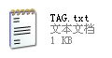file
2015-01-01 23:59:59
StampMode:1
poweron_record:1
auto_poweroff:1
recording_indicator:1
Rotate Photos 180:0
Loop recording:0
Video size:1
**************************************
Time:2015-12-01 00:00:00
modification time
StampMode:1
0 (time 0ff),
1 (time on)
poweron_record:1
0 0ff, Power on no record
1 on, Power on auto record
auto_poweroff:1
0 off NO auto Power off
1 2min auto power off
recording_indicator:1
0 LED OFF
1 LED ON
Rotate Photos 180°：0
0 No Roate
1 Rotate Photos 180
Loop recording: 0
0 no loop recording A package of 2GB file
1 A package of 3mins file loop recording
Video size: 1
1 1920*1080
2 1280*720
***************************************
including:
1 x mate 808 camera (Not include the Memory Card)
1 x USB cable
1 x AV cable
1 x FPV cable
1 x user manual
1 x VELCRO

