Nautilus Waterproof Action Camera
User Manual
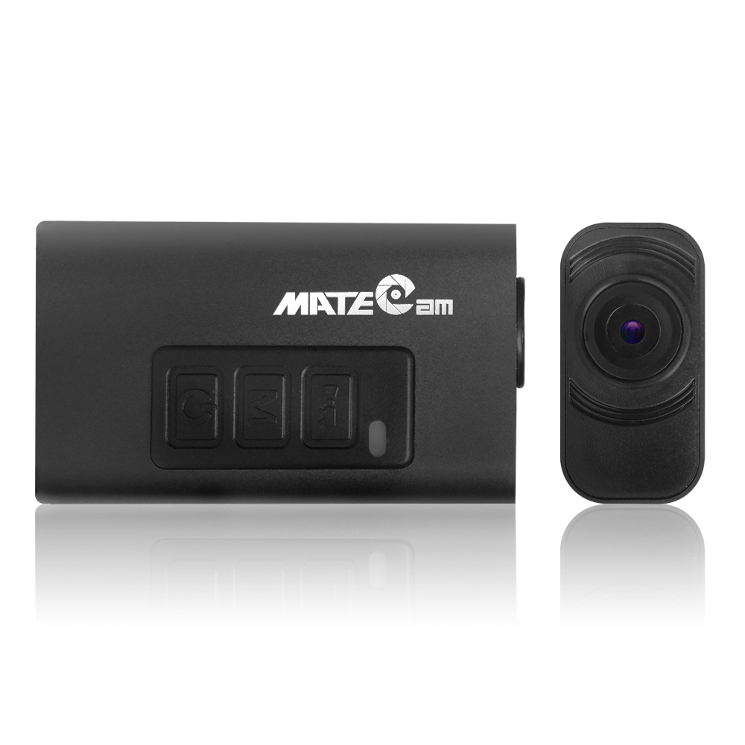
Specification
Image Sensor | 1/2.7" 1080P HD Color COMS Sensor OV2710
Max Resolution | 2.0 Mega Pixels
Video Record | 1920X1080 30fps / 1280X720 60fps H.264 .MOV
WIFI | Action DVR Password: 00000000
Application | iSmart DV
Waterproof Depth | 5 Meters / 15 feet
Lens | 6 Glass,F=2.4,f=3.0,diagonal 115°/ horizontal 103° / vertical angle 92°
Memory | External: Micro SD CARD UP TO 32GB
I / O terminals | USB 2.0
TV-OUT | PAL/NTSC
G-SENSOR | YES

Charging:
- When you receive your new camera it’s recommended you first charge the battery.
- Using the supplied USB cable connect the Camera to a PC USB port.
- The Red LED will remain on during charging.
- The Red LED will turn off after fully charged.
Operating Instructions:
FUNCATION KEYS CHART:
Key | Name | Functions | Functions if  Connected to TV or to Monitor
 | Shutter | Power on, recording starts,  Default 1080P,  Press to start or stop video recording | Under playback mode,  Move down to select video
 | Mode | Press and Switch between 5 modes:  ① 1080p@30fps  ② 720P@60fps  ③ Image@3M  ④ Motion detect  ⑤ WIFI ON | Press and Switch between 4 modes:  ① 1080p@30fps  ② 720P@60fps  ③ Image@8M  ④ Playback mode
 | Power | Press 3 seconds to Power on/off | Press 3 seconds to Power on/off,  Under playback mode, Move up to select video

Power Button:
- Press power button for 3 seconds to turn camera ON / OFF
- Turning camera ON automatically starts video recording at 1080P (Default)
- LED will (slow blink) when recording.
Shutter Button:
- Press the shutter button to stop or to start video recording.
Mode Button:
- With camera in standby mode (solid LED) Press the Mode button to circulate the 4 LED color for selecting 4 different modes, Red, Green, Orange, Blue(Please see LED Color Chart below.)
- To resume recording in selected Mode, Press the shutter button.
WIFI MODE:
- Press MODE button for 3 seconds to turn on WIFI function ON/OFF, Blue LED ON.
- Install “iSmart DV” . apk or .ios file
- Connect to the SSID “Action DVR” WIFI, default Password:00000000

LED COLOR CHART:
Instructions of LED Colors and Flashing in Different Modes
Status |  | 1080P@30fps | 720P@60fps | 8.0 Mega Photo | Motion detect mode
Camera stand by |  | Red (Stable) | Green (Stable) | Orange (Stable) | Blue quick flashing alternately
Video recording  or taking photo |  | Red (Slow Flashing) | Green (Slow Flashing) | Orange (Slow Flashing) | Auto recording and Stop. Blue and Red slow flashing alternately.
WIFI ON |  | Red (Slow Flashing)and Blue(Stable) | Green (Slow Flashing)and Blue(Stable)
SD Card is full |  | Red (Flash quickly for 3 times then stop) | Green (Flash quickly for 3 times then stop) | Orange (Flash quickly for 3 times then stop) | Loop Video recording
Battery down |  | Red (Camera off after quick flashing) | Green(Camera off after quick flashing) | Orange (Camera off after quick flashing) | Red and Green (Camera off after quick flashing)
Battery | Charging | Red (Stable)
Battery | Full Charged | Red (Off)
No SD Card |  | Red and Green (Camera off after quick flashing )
Connecting PC | Camera ON | Red (stable) Recording
Connecting PC | Camera OFF | Orange (Stable) Charging
Firmware Upgrading |  | Green (Flashing)

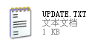
Camera Setup:
- UPDATE:N
- Time:2015/03/31-21:52:00
- Image Size:1
- Seamless:3
- G_Sensor:1
- Stamp Mode:1
- Power on_record:1
- Password:00000000
- auto_power off:1
- Video sound:1
- recording_indicator:1
- Lapse time:0
- TV_mode:0
- EV:3
- Reset:0
- ------VER:DW20150601------
- UPDATE()
- N ~ Y, def:N, If you want to change the device's settings, please UPDATE: N to Y
- Image Size()
- 1 ~ 7, def:1, 1(10M), 2(8M), 3(6M), 4(5M), 5(3M), 6(2M), 7(VGA)
- Seamless(Continuous Loop Recording)
- 0 , 4, def:0, 0(No Continuous Loop Recording), 1(Continuous Loop Recording 1mins), 2(3min), 3(5min), 4(10min)
- G_Sensor()
- 0 , 3, def:1, 0(off), 1(16G), 2(8G), 3(4G)
- Stamp Mode()
- 0 , 1 def:1, 0(0ff), 1(on)
- Power on_record()
- 0 , 1 def:1, 0(0ff), 1(on)
- Password()
- 0 - 9 def:00000000, Use only the numbers 0-9
- auto_power off()
- 0 , 2 def 1, 0(off), 1(1min), 2(2min)
- Video sound()
- 0 , 1 def:1, 0(0ff), 1(on)
- recording_indicator
- 0 , 1 def:1, 0(0ff), 1(on)
- Lapse time() In Capture mode
- 0 , 4, def:0, 0(off), 1(5S), 2(15S), 3(30S), 4(60S)
- TV_mode()
- 0 , 1, def:0, 0(PAL,16:9), 1(NTSC,4:3)
- EV()
- 0 , 6, def:3, 0(-2), 1(-1.5), 2(-1), 3(0), 4(1), 5(1.5), 6(2)
- Factory Reset(Reset)
- 0 ~ 1, def:0, 1(Restoring the Default Settings)

A/V Out Cable:
- The Optional RCA Audio/Video cable connects camera to TV or Monitor, camera in "1080p@30fps mode", and automatically record.
- Press the Shutter, recording stop.
- Press the Mode button to circulate the 4 LED color for selecting 4 different modes, Red, Green, Orange, Red/Green, see Function Key Chart.
- Under the Playback Mode, Press Shutter and Power buttons to scroll up/down recorded videos.
Web Cam Mode:
- Turn off camera, Connect it to your PC and the camera will be in charge mode.
- Press MODE button once, the icon of web cam appear in the page of “My Computer”.
- If this is the first time using web cam mode, drivers will be automatically downloaded to your PC. After drivers are installed, (Repeat) In charging mode, Press MODE button again to start web cam mode.
- Open your favorite web cam software such as AMCap to view the live video 640x480.
Troubleshooting:
Please charge at least 1 hour and reset camera before use. You can use the 'Web Cam Mode' described above to test the camera and please remember to plug memory card into the camera. if the 'Web Cam Mode' works, then the camera is OK. If it is not working, please refer to the following solution.
1.Can’t turn on the Camera: Connect to the power supply. If camera can be turned on, then the battery is exhausted. This product is not charged at the factory, please charge it at least 2 hours before use for the first time.
2.The LED doesn’t flash or record video or take photos when turning the camera on:
- If the memory card is full, please insert an empty Class 10 memory card.
- Battery is exhausted.
3.Video blur: upgrade the camera software
4.Can't connect to PC:
a.Please use the USB cable provided by us and check if the USB cable is in the right position
b.Check if the memory card is inserted in place, or change memory card.
5.video pause, fast, no sound:
a,memory shortage of the computer, please clean the buffer.
b.Player. Please choose the player which support H.264
6.Camera keys will not respond at all: Reset the camera, Use a staple, pin or similar object to carefully toggle the ‘RESET button’ on the side.
If the above methods are invalid, then the machine might be damaged, please contact us to return or replace
Package Includes:
1 x Nautilus cam (No Memory Card)
1 x Nautilus cam Holder
1 x USB cable
1 x AV-OUT cable
1 x Velcro
1 x User manual

